**Program list PL-IV**

1.Perform a program for Implementation of matrix operations like addition, substraction, multiplication. simple, multidimensional .

**2**.Implement Following:

Interface exam with percentage_cal() method

Create class student with variables name, rollno, marks1, marks2 and display() method

Class result inherits student class and implements exam interface.

Demonstrate these classes with application.

**3**.Implement Following:

Create abstract class shape with dim1, dim2 variables and disp(), abstract area() methods.

Class rectangle with getd() and area() methods.

Class triangle with getd() and area() methods. Demonstrate all classes in application.

**4.**Write a program to Implement the concept of multilevel inheritance by using following exampleTake the input of 3 students i.e. Id, Roll no and marks of 5 subjects of each student and calculate percentage marks of each student.

Student class-> Test class-> Result class

**5**.Perform the program to Implement the operations on a string by using string class. The operations are as follows.

1.Length 2.CompareTo() 3.Equals() 4.Uppercase()

5.Trim() 6. .Concat() 7.Substring() 8.Insert()

and perform the following for stringbuilder class

1.Append() 2..Insert() 3.Remove() 4.Replace()

**6.**Perform the program for Implementation of Calculator by using Windows Form Application

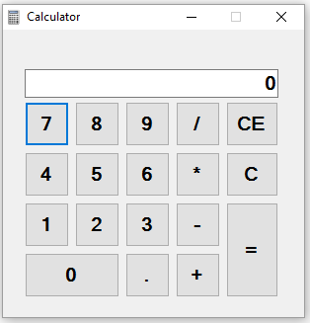

**7.**perform the program for Implementation of windows form database connectivity for successfully login application. And use progress bar control for password field to show the entered password strength.



**8.**perform the program for Implementation of windows form application for validation of field and passing the data to the next form.

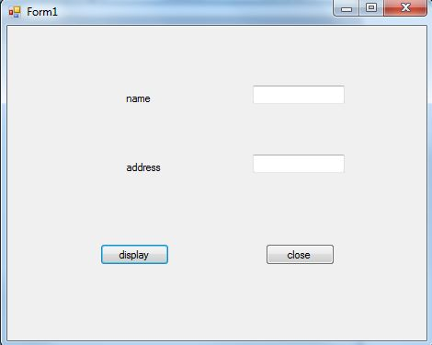 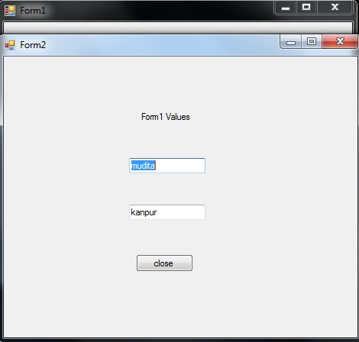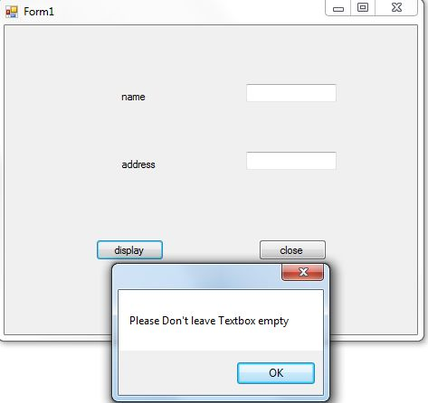

**9.**Develope a windows form application to insert, delete, retrieve and update the student database .

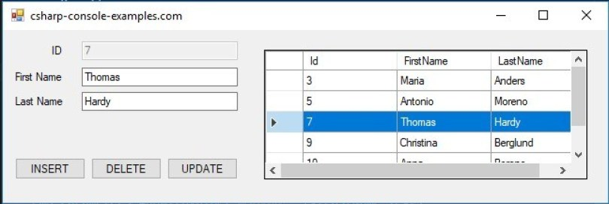

**10.**Write a program which will find the match words that start with 'm' and ends with 'e' for the given string “make maze and manage to measure it”

**11.**.Write a C# program to accept the sentence from user and perform the following operations .

1. Claculate length of the sentence

2. Reverse the sentence

3. Calculate number of vowels in the sentence

**12.**.Write a program to implement the concept of regular expression in C# for pattern matching for doing following operations.

1.Remove the comma and Space from the sentence.

2.Find out the words which starts and ends with some letter.

**13.**Write a program to implement the concept of Abstract class for calculating and displaying the area of Reactangle class, Square class and circle class.

Abstract class-AreaCalculate

Abstract Methods

1.Void Area();

2.Void Display();

**14.**Write a program to implement the concept of delegate in c# by using any application.

1.Single Delegate

2.Multicast Delegate

15. Define a class called MyString with the following features:

1. An overloaded binary + operator that concatenates two MyString objects and create a third object.
2. An Overloaded comparison operator == to compare two strings.
3. An overloaded unary – (minus) operator that returns true if the string object is empty, otherwise false.

**16.**Assume that a book maintains two kind of accounts for customers, one called savings account and the other current account. The savings account provides compound interest and withdrawal facilities but no cheque book facility. The current account provides cheque book facility but no interest. Current account holders should also maintain a minimum balance and if the balance falls below this level , a service charge is imposed. Create a class Account that stores customer name, account number and type of account. From this derive the classes Cur-Acct and Sav-Acct to make them more specific to their requirements. Include the necessary member methods in order to accomplish the following tasks a. Accept deposit from a customer and update the balance. B. Display the balance. C. Compute and deposit interest. D. Permit withdrawal and update the balance. E. Check for the minimum balance, impose penalty, if necessary and update the balance.Do not use any constructor .Use member methods to initialize the class members.

17. Define a base class called Animal with following members: a. A string type data member to store the name of the animal. b. An integer member to store the age of the animal in years. C. A method to display the name and age of the animal. Derive two classes named cat and dog from Animal class. Then, write a driver program to create cat and dog objects with suitable values. Display the contents of the objects by calling the Display method on the derived objects. Modify the program Implement Display in cat class. a. Implement Display in dog class with the new modifier. B. Modify the driver program such that base version as well as derived version of Display are called.

**18.**.Write a C# program to implement the Concept of interface for Banking Account

Account->Parent Class

1.Account Id

2.Account Holder Name

3.Address

4.Phone Number

Child Classes are

**1.Current Account**

1.Amount

2.MaxDebitLimit

**2.Saving Account**

1.Amount

2.Minimum Amount

3.Interest Rate

Implement the interface

Deposit Amount->Implemented by current and saving account classes

1.Deposit by account in cash